OVERVIEW OF THE DRUG TREATMENT COURT IN BARBADOS

Alternatives to incarceration have been a subject of discussion in Barbados for some time. Judges and magistrates within the discretion given to them by law on occasion have explored innovative ways to deal with offenders other than sending them to prison. The initiative of the Inter American Drug Abuse Control Commission (CICAD) to promote a hemispheric project on Drug Treatment Courts (DTCs) as an alternative to incarceration was therefore seen by the government as a positive development.

In December 2010, Barbados indicated its willingness to join the CICAD project and in March 2012 a team led by the Honourable Adriel Brathwaite, Attorney General and Minister of Home Affairs and including Chief Justice Sir Marston Gibson participated in a Study Visit and Exchange Program for the Caribbean to Toronto, Canada. These officials were able to observe DTCs in operation in Toronto, to speak to judicial officials and to share experiences with other participating Caribbean jurisdictions. The Attorney General indicated on his return to Barbados that he was impressed by what he saw and was convinced that the country should explore the introduction of a DTC pilot.

In June 2012 another major step towards the introduction of the DTC in Barbados was taken when the country hosted a “Sensitization Workshop” in collaboration with CICAD and the Canadian Association of Drug Treatment Court Professionals (CADTCP). The Workshop presented the model to judicial, medical and other stakeholders and explored the steps necessary for the successful establishment of the pilot.

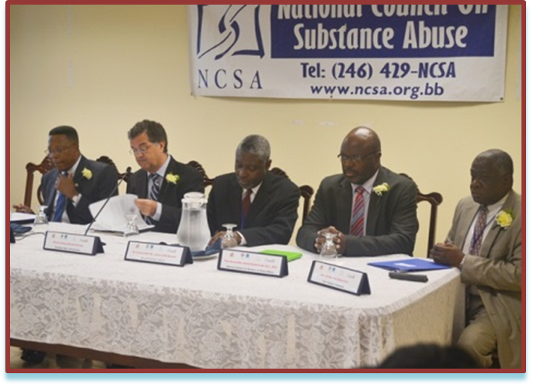
In March 2013, Barbados joined the fraternity of countries with DTCs when the Honourable Adriel Brathwaite signed a Memorandum of Understanding (MOU) with CICAD to implement the DTC model. The MOU formalized the participation of Barbados in the hemispheric project and detailed the technical assistance which would be provided by CICAD to support the initiative.

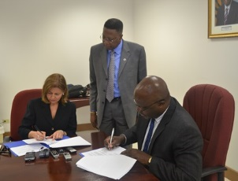
In April 2013, in support of the earlier efforts, a CICAD DTC team including experts from Canada held a Training Workshop at the Supreme Court of Barbados for a wide range of stakeholders. The Workshop focused on general and specific aspects of DTCs and measures to ensure the successful implementation of the model. The Barbados participants were able to draw on the countries experiences of Jamaica and Trinidad and Tobago which together were represented by a High Court Judge, a Magistrate and the Head of a National Drug Commission.

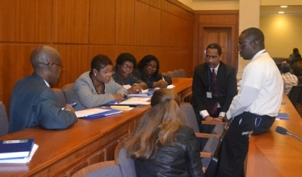

On February 11, 2014 Barbados formally inaugurated the country's first pilot Drug Treatment Court as an alternative to incarceration for drug dependent offenders, at the Supreme Court in the city of Bridgetown. The launching of this Court represented the culmination of a period of three years of preparatory work supported by the Organization of American States (OAS) through the Inter-American Drug Abuse Control Commission (CICAD), with funding from the Government of Canada.

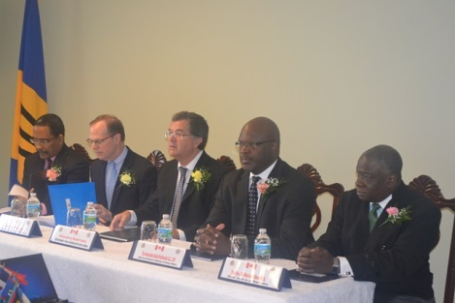

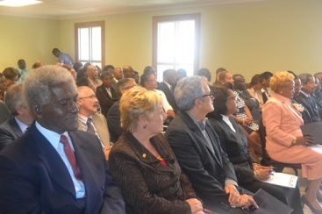

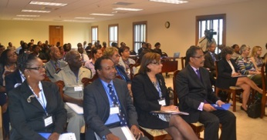

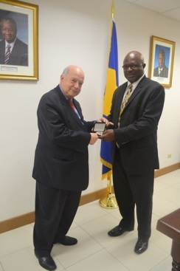

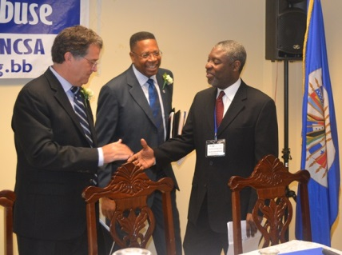

The official launch of the Court had participation from the Attorney General and Minister of Home Affairs, Honourable Adriel Brathwaite, Chief Justice Marston Gibson, High Court Judge Randall Worrell and other senior judicial and government officials. The Executive Secretary of CICAD, Ambassador Paul Simons accompanied by Antonio Lomba, DTC Project Manager travelled to Barbados for the event. The Canadian Government which has provided funding and training support for the CICAD project was represented by High Commissioner Richard Hanley.

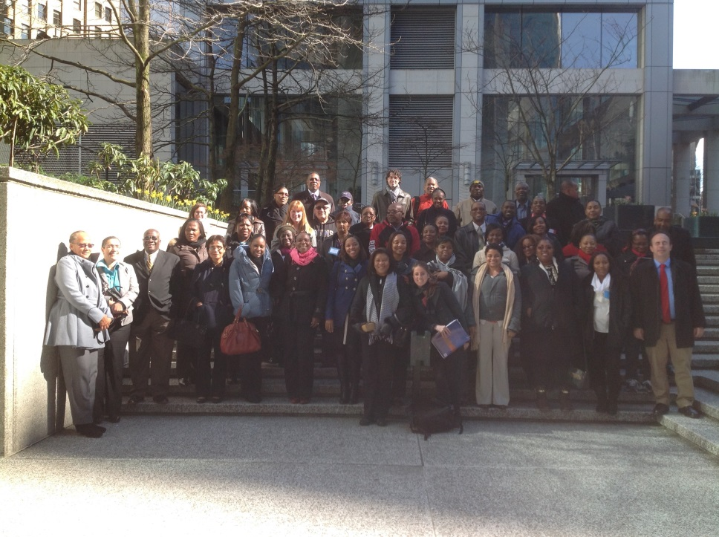
The Barbados DTC team was exposed to further training in March 2014 when CICAD extended an invitation for a High Level Study Visit and Training in Vancouver, Canada. The Study Visit coincided with the celebration of the Fifth International Conference on Problem Solving Courts and Innovative Approaches to Justice of the CADTCP. The Conference allowed participants to benefit from a range of expert presentations on Problem Solving Courts, restorative justice, substance abuse, mental health issues, and innovative approaches to justice. The Barbados DTC team was led by the Chief justice, Sir Marston Gibson and included several senior officials who will participate in the Drug Treatment Court pilot.

